Relationships Education, Health Education and Sex Education in Primary Schools
Information for parents/carers

What are the aims of Relationships Education, Sex Education and Health Education in the primary school?
The opening paragraph of the Department for Education guidance states: “Today’s children and young people are growing up in an increasingly complex world and living their lives seamlessly on and offline. This presents many positive and exciting opportunities, but also challenges and risks. In this environment, children and young people need to know how to be safe and healthy, and how to manage their academic, personal and social lives in a positive way.” (DfE, 2019, Relationships Education, Relationships and Sex Education and Health Education)

What are the new RSE requirements?
- We must provide the following to all pupils
- Relationships education
- Health education

- We aren’t required to provide sex education

By the end of primary school pupils will know about:-

Relationships Education Health Education
Families and people who care for me Mental wellbeing
Caring Friendships Internet safety and harms
Respectful Relationships Physical health and fitness
Online Relationships Healthy Eating
Being safe Drugs, alcohol and tobacco Health and prevention
Basic first aid
Changing adolescent body (science)
(yrs 5 and 6)
Science: YR5- describe the life process of reproduction in some plants and animals /describe the changes as humans develop to old age
-YR6- recognise that living things produce offspring of the same kind, but normally offspring vary and are not identical to their parents recognise the impact of diet, exercise, drugs and lifestyle on the way their bodies function

Programme of study for KS1 and KS2
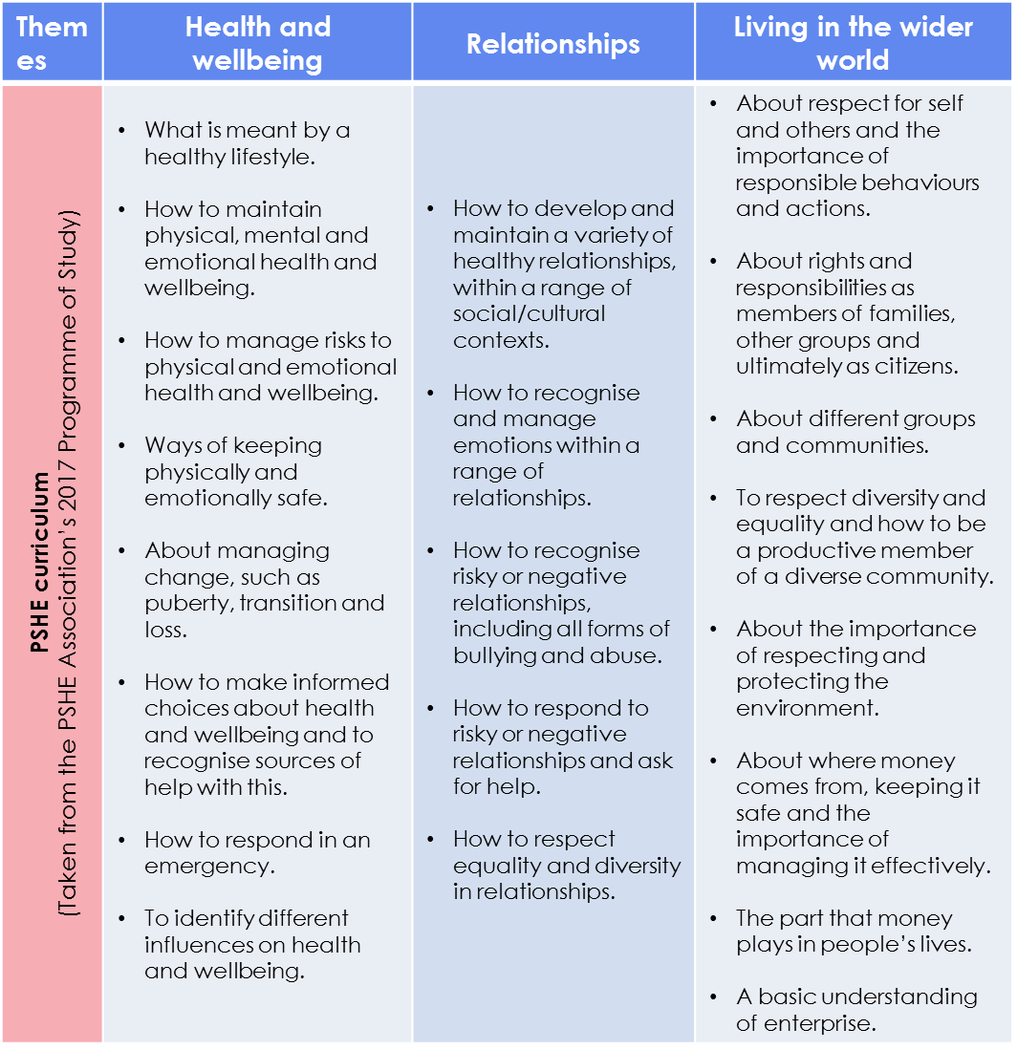

What does our curriculum look like now?

- What are your thoughts on our current curriculum for RSE? Do you think this curriculum meets your child’s needs?
- What do we do well? What could we do better?
- Is there anything we’re not covering that you think we need to address?
- Is there something we could cover more/less?
- What do you think about the way we currently deliver RHE to pupils?
- As a parent, do you feel like you need more information or guidance on specific topics?

Feedback:- j.conway@linacreprimary.net

